**EXERCISE - 2**

**Question 1: Students Table** Create a table named **Students** with the following columns:

· **student_id** as the primary key

· **first_name** of type VARCHAR2 with a maximum length of 50 (not null)

· **last_name** of type VARCHAR2 with a maximum length of 50 (not null)

· **birthdate** of type DATE (not null)

**SOLUTION:**

SQL> CREATE TABLE Students (

2 student_id NUMBER PRIMARY KEY,

3 first_name VARCHAR2(50) NOT NULL,

4 last_name VARCHAR2(50) NOT NULL,

5 birthdate DATE NOT NULL

6* );

Table STUDENTS created.

**Question 2: Products Table** Create a table named **Products** with the following columns:

· **product_id** as the primary key

· **product_name** of type VARCHAR2 with a maximum length of 100 (not null)

· **price** of type NUMBER with precision 10 and scale 2 (not null)

· **quantity_in_stock** of type NUMBER with precision 5 (not null)

**SOLUTION:**

SQL> CREATE TABLE Products (

2 product_id NUMBER PRIMARY KEY,

3 product_name VARCHAR2(100) NOT NULL,

4 price NUMBER(10, 2) NOT NULL,

5 quantity_in_stock NUMBER(5) NOT NULL

6* );

Table PRODUCTS created.

**Question 3: Employees Table** Create a table named **Employees** with the following columns:

· **employee_id** as the primary key

· **first_name** of type VARCHAR2 with a maximum length of 50 (not null)

· **last_name** of type VARCHAR2 with a maximum length of 50 (not null)

· **hire_date** of type DATE (not null)

· **salary** of type NUMBER with precision 10 and scale 2 (not null)

**SOLUTION:**

SQL> CREATE TABLE Employees (

2 employee_id NUMBER PRIMARY KEY,

3 first_name VARCHAR2(50) NOT NULL,

4 last_name VARCHAR2(50) NOT NULL,

5 hire_date DATE NOT NULL,

6 salary NUMBER(10, 2) NOT NULL

7* );

Table EMPLOYEES created.

**Question 4: Orders Table** Create a table named **Orders** with the following columns:

· **order_id** as the primary key

· **order_date** of type DATE (not null)

· **customer_name** of type VARCHAR2 with a maximum length of 100 (not null)

· **total_amount** of type NUMBER with precision 10 and scale 2 (not null)

**SOLUTION:**

SQL> CREATE TABLE Orders (

2 order_id NUMBER PRIMARY KEY,

3 order_date DATE NOT NULL,

4 customer_name VARCHAR2(100) NOT NULL,

5 total_amount NUMBER(10, 2) NOT NULL

6* );

Table ORDERS created.

**Question 5: Books Table** Create a table named **Books** with the following columns:

· **book_id** as the primary key

· **title** of type VARCHAR2 with a maximum length of 200 (not null)

· **author** of type VARCHAR2 with a maximum length of 150 (not null)

· **publication_date** of type DATE (not null)

· **price** of type NUMBER with precision 10 and scale 2 (not null)

**SOLUTION:**

SQL> CREATE TABLE Books (

2 book_id NUMBER PRIMARY KEY,

3 title VARCHAR2(200) NOT NULL,

4 author VARCHAR2(150) NOT NULL,

5 publication_date DATE NOT NULL,

6 price NUMBER(10, 2) NOT NULL

7* );

Table BOOKS created.

**Students Table:**

1. Insert a new student named "Alice Johnson" with a birthdate of January 5, 2000, into the **Students** table.

**SOLUTION**

SQL> INSERT INTO Students (student_id, first_name, last_name, birthdate)

2* VALUES (1,'Alice', 'Johnson', TO_DATE('2000-01-05', 'YYYY-MM-DD'));

1 row inserted.

2. Add a student record for "Mark Smith" with a birthdate of November 15, 2001, to the **Students** table.

**SOLUTION**

SQL> INSERT INTO Students (student_id, first_name, last_name, birthdate)

2* VALUES (2,'Mark', 'Smith', TO_DATE('2001-11-15', 'YYYY-MM-DD'));

1 row inserted.

3. Insert the details of a student named "Emily Davis" with a birthdate of April 30, 1999, into the **Students** table.

**SOLUTION**

SQL> INSERT INTO Students (student_id, first_name, last_name, birthdate)

2* VALUES (3,'Emily', 'Davis', TO_DATE('1999-04-30', 'YYYY-MM-DD'));

1 row inserted.

4. Add a record for "Michael Brown" with a birthdate of July 8, 1998, to the **Students** table.

**SOLUTION**

SQL> INSERT INTO Students (student_id, first_name, last_name, birthdate)

2* VALUES (4,'Michael', 'Brown', TO_DATE('1998-07-08', 'YYYY-MM-DD'));

1 row inserted.

5. Insert a student named "Sophia Wilson" with a birthdate of September 12, 2002, into the **Students** table.

**SOLUTION**

SQL> INSERT INTO Students (student_id, first_name, last_name, birthdate)

2* VALUES (5,'Sophia', 'Wilson', TO_DATE('2002-09-12', 'YYYY-MM-DD'));

1 row inserted.

**Products Table:**

1. Insert a new product named "Tablet" with a price of $299.99 and a quantity in stock of 50 into the **Products** table.

**SOLUTION**

SQL> INSERT INTO Products (product_id,product_name, price, quantity_in_stock)

2* VALUES (1,'Tablet', 299.99, 50);

1 row inserted.

2. Add a product named "Bluetooth Speaker" with a price of $39.99 and a quantity in stock of 150 to the **Products** table.

**SOLUTION**

SQL> INSERT INTO Products (product_id,product_name, price, quantity_in_stock)

2* VALUES (2,'Bluetooth Speaker', 39.99, 150);

1 row inserted.

3. Insert a product named "Camera" with a price of $599.00 and a quantity in stock of 25 into the **Products** table.

**SOLUTION**

SQL> INSERT INTO Products (product_id, product_name, price, quantity_in_stock)

2* VALUES (3,'Camera', 599.00, 25);

1 row inserted.

4. Add a new product named "External Hard Drive" with a price of $89.50 and a quantity in stock of 80 into the **Products** table.

**SOLUTION**

SQL> INSERT INTO Products (product_id, product_name, price, quantity_in_stock)

2* VALUES (4,'External Hard Drive', 89.50, 80);

1 row inserted.

5. Insert a product named "Wireless Mouse" with a price of $19.99 and a quantity in stock of 200 into the **Products** table.

**SOLUTION**

SQL> INSERT INTO Products (product_id, product_name, price, quantity_in_stock)

2* VALUES (5,'Wireless Mouse', 19.99, 200);

1 row inserted.

**Employees Table:**

1. Insert a new employee named "David Johnson" hired on March 10, 2023, with a salary of $55000.00 into the **Employees** table.

**SOLUTION**

SQL> INSERT INTO Employees (employee_id, first_name, last_name, hire_date, salary)

2* VALUES (1,'David', 'Johnson', TO_DATE('2023-03-10', 'YYYY-MM-DD'), 55000.00);

1 row inserted.

2. Add an employee named "Jessica Williams" hired on January 20, 2022, with a salary of $60000.00 to the **Employees** table.

**SOLUTION**

SQL> INSERT INTO Employees (employee_id, first_name, last_name, hire_date, salary)

2* VALUES (2,'Jessica', 'Williams', TO_DATE('2022-01-20', 'YYYY-MM-DD'), 60000.00);

1 row inserted.

3. Insert an employee named "Daniel Brown" hired on June 5, 2023, with a salary of $48000.00 into the **Employees** table.

**SOLUTION**

SQL> INSERT INTO Employees (employee_id, first_name, last_name, hire_date, salary)

2* VALUES (3,'Daniel', 'Brown', TO_DATE('2023-06-05', 'YYYY-MM-DD'), 48000.00);

1 row inserted.

4. Add a new employee named "Laura Davis" hired on November 2, 2022, with a salary of $52000.00 into the **Employees** table.

**SOLUTION**

SQL> INSERT INTO Employees (employee_id, first_name, last_name, hire_date, salary)

2* VALUES (4, 'Laura', 'Davis', TO_DATE('2022-11-02', 'YYYY-MM-DD'), 52000.00);

1 row inserted.

5. Insert an employee named "Matthew Wilson" hired on August 15, 2023, with a salary of $54000.00 into the **Employees** table.

**SOLUTION**

SQL> INSERT INTO Employees (employee_id, first_name, last_name, hire_date, salary)

2* VALUES (5,'Matthew', 'Wilson', TO_DATE('2023-08-15', 'YYYY-MM-DD'), 54000.00);

1 row inserted.

**Orders Table:**

1. Place an order with today's date for a customer named "John Smith" with a total amount of $125.75 in the **Orders** table.

**SOLUTION**

SQL> INSERT INTO Orders (order_id, order_date, customer_name, total_amount)

2* VALUES (1, SYSDATE, 'John Smith', 125.75);

1 row inserted.

2. Insert an order with today's date for a customer named "Mary Johnson" with a total amount of $95.50 into the **Orders** table.

**SOLUTION**

SQL> INSERT INTO Orders (order_id, order_date, customer_name, total_amount)

2* VALUES (2, SYSDATE, 'Mary Johnson', 95.50);

1 row inserted.

3. Place an order with today's date for a customer named "Robert Davis" with a total amount of $200.25 in the **Orders** table.

**SOLUTION**

SQL> INSERT INTO Orders (order_id, order_date, customer_name, total_amount)

2* VALUES (3, SYSDATE, 'Robert Davis', 200.25);

1 row inserted.

4. Insert an order with today's date for a customer named "Jennifer Wilson" with a total amount of $150.00 into the **Orders** table.

**SOLUTION**

SQL> INSERT INTO Orders (order_id, order_date, customer_name, total_amount)

2* VALUES (4, SYSDATE, 'Jennifer Wilson', 150.00);

1 row inserted.

5. Place an order with today's date for a customer named "Emily Brown" with a total amount of $80.99 in the **Orders** table.

**SOLUTION**

SQL> INSERT INTO Orders (order_id, order_date, customer_name, total_amount)

2* VALUES (5, SYSDATE, 'Emily Brown', 80.99);

1 row inserted.

**Books Table:**

1. Insert a book titled "1984" by "George Orwell" published on June 8, 1949, with a price of $11.99 into the **Books** table.

**SOLUTION**

SQL> INSERT INTO Books (book_id, title, author, publication_date, price)

2* VALUES (1, '1984', 'George Orwell', TO_DATE('1949-06-08', 'YYYY-MM-DD'), 11.99);

1 row inserted.

2. Add a book titled "Pride and Prejudice" by "Jane Austen" published on January 28, 1813, with a price of $9.50 into the **Books** table.

**SOLUTION**

SQL> INSERT INTO Books (book_id, title, author, publication_date, price)

2* VALUES (2, 'Pride and Prejudice', 'Jane Austen', TO_DATE('1951-07-16', 'YYYY-MM-DD'), 12.25);

1 row inserted.

3. Insert a book titled "The Catcher in the Rye" by "J.D. Salinger" published on July 16, 1951, with a price of $12.25 into the **Books** table.

**SOLUTION**

SQL> INSERT INTO Books (book_id, title, author, publication_date, price)

2* VALUES (3, 'The Catcher in the Rye', 'J.D. Salinger', TO_DATE('1951-07-16', 'YYYY-MM-DD'), 12.25);

1 row inserted.

4. Add a book titled "The Lord of the Rings" by "J.R.R. Tolkien" published on July 29, 1954, with a price of $18.99 into the **Books** table.

**SOLUTION**

SQL> INSERT INTO Books (book_id, title, author, publication_date, price)

2* VALUES (4, 'The Lord of the Rings', 'J.R.R. Tolkien', TO_DATE('1954-07-29', 'YYYY-MM-DD'), 18.99);

1 row inserted.

5. Insert a book titled "Harry Potter and the Sorcerer's Stone" by "J.K. Rowling" published on June 26, 1997, with a price of $14.50 into the **Books** table.

**SOLUTION**

SQL> INSERT INTO Books (book_id, title, author, publication_date, price)

2* VALUES (5, 'Harry Potter and the Sorcerer''s Stone', 'J. K. Rowling', TO_DATE('1997-07-26', 'YYYY-MM-DD'), 14.50);

1 row inserted.

**DATA RETRIEVAL FROM STUDENTS TABLE.**

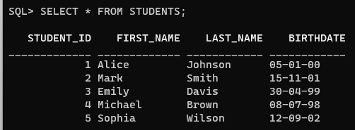

**DATA RETRIEVAL FROM EMPLOYEES TABLE.**

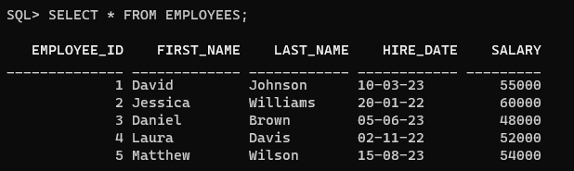

**DATA RETRIEVAL FROM ORDERS TABLE.**

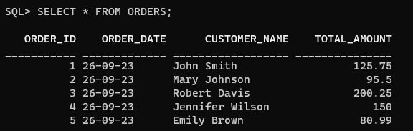

**DATA RETRIEVAL FROM BOOKS TABLE.**

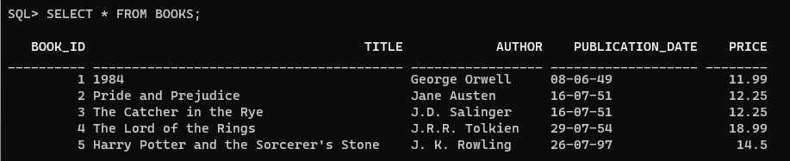

**DATA RETRIEVAL FROM PRODUCTS TABLE.**

